Wireless Sample 2 User’s Manual

Wireless Sample 2 (WS2) is located in $TOSROOT/apps/WS2-ARQ.

Installation
The WS2 Imote2 firmware must be installed on each mote that is attached to the structure being monitored.
- cd $TOSROOT/apps/WS2-ARQ
- make imote2 debug
  - ignore the make error messages at the end
- USBLoaderHost.exe –p build/imote2/main.bin.out
  - Make sure the USB cable is connected directly to the mote.

TOSBase must be installed on the mote that is attached to the computer.
- cd $TOSROOT/apps/TOSBase
- make imote2 debug
  - ignore the make error messages at the end
- USBLoaderHost.exe –p build/imote2/main.bin.out
  - Make sure the USB cable is connected directly to the mote (not to the debug board).

The Java WS2 application serves as the user interface for controlling the wireless network.
- cd $TOSROOT/apps/WS2-ARQ/java
- make

Executon
After installing the WS2 firmware on the Imote2s, and TOSBase on the gateway Imote2, perform the following to launch the application:
- cd $TOSROOT/apps/WS2-ARQ/java
- java net.tinyos.sf.SerialForwarder –comm serial@COM3:115200 &
- java WS2
Note that you must change COM3 to whatever serial port your gateway mote is attached to as specified in Device Manager.

You should see the following user interface:
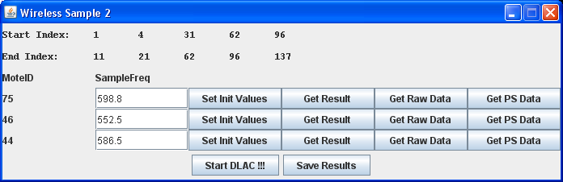
- Ensure that the start and end search frequencies as shown on the top of the user interface are correct.
- Ensure that the sampling frequency of each mote is correct.
- Note that each of the
- Hit the “Set Init Values” of each mote. Observe the green LED blinking on the mote.
- Hit the “Start DLAC !!!” button.
  - You will see the blue LED blink 6 times, pause, and then blink 6 times again. It will repeat this each time it takes a set of accelerometer readings.
  - Once it is done performing the root calculation, it will turn on the green LED.
  - You must wait for the green LED to turn on before continuing!
  - The red LED will blink if an error condition has occurred.
- Once the green LED has turned on, you can hit the “Get Result” button on each mote, which will retrieve the root calculations.
- To validate, you can also click the “Get Raw Data” button on each mote, which will grab the raw sensor readings.
- The Get PS Data will return a portion of the power spectrum data for validation purposes.
- Click on “Save Results” to save the data to a file. Note the command line output to see where the files are saved.

Control Knobs

Sampling Frequencies
The sampling frequency of each mote is specified in $TOSROOT/apps/WS2-ARQ/java/MoteSettings.txt. This file contains two tab-separated columns: the first is the Mote ID in hexadecimal notation (it is the last two digits of the mote’s label), the second column is the sampling frequency in Hz.

Start and End Search Frequencies
The start and end search frequencies are specified in $TOSROOT/apps/WS2-ARQ/java/StatEndFreq.txt. This contains 5 tab-separated columns and two rows. The first row specifies the start frequencies and the second row specifies the end frequencies.

Number of Samples to Average
- Open $TOSROOT/apps/WS2-ARQ/ControllerP.nc and edit NUM_AVG on line 24.
- You must re-compile and re-upload WS2-ARQ onto the motes for this to take effect.

Wait Interval Between Samples
- Open $TOSROOT/apps/WS2-ARQ/ControllerP.nc and edit AVG_WAIT on line 25.
- The value is in binary milliseconds (1024 = 1s).
- The default value is 1024.
- You must re-compile and re-upload WS2-ARQ onto the motes for this to take effect.

LED Behavior
- WS2 rapidly blinks the blue LED 6 times every time it starts taking a set of raw accelerometer readings.
- WS2 turns on the green LED when it is done taking the samples, averaging the power spectrum, and calculating the roots.
- WS2 blinks the red LED whenever an error has occurred

